Multimodal Deepfake and Synthetic Media Detector
Akash SM  Department of Computer Science  and Engineering,  Faculty of Engineering and  Technology, Jain University,  Bengaluru, Karnataka, India | Avinash GK  Department of Computer Science  and Engineering,  Faculty of Engineering and  Technology, Jain University,  Bengaluru, Karnataka, India | Aditya K  Department of Computer Science  and Engineering,  Faculty of Engineering and  Technology, Jain University,  Bengaluru, Karnataka, India
Aryan Agrawal  Department of Computer Science  and Engineering,  Faculty of Engineering and  Technology, Jain University,  Bengaluru, Karnataka, India | Devansh Gupta M  Department of Computer Science  and Engineering,  Faculty of Engineering and  Technology, Jain University,  Bengaluru, Karnataka, India | Druvraaj  Department of Computer Science  and Engineering,  Faculty of Engineering and  Technology, Jain University,  Bengaluru, Karnataka, India

1. ABSTRACT
The rapid advancement of deep learning has enabled the creation of highly realistic synthetic media, commonly referred to as deepfakes, where both facial appearance and voice can be convincingly manipulated within video content. The increasing accessibility of such technologies

poses serious threats to digital trust, misinformation control, and personal security, necessitating the development of robust and reliable detection systems. Traditional deepfake detection approaches predominantly rely on visual
analysis alone, making them insufficient for detecting modern multimodal deepfakes that simultaneously manipulate both visual and audio streams.

This project presents a multimodal deepfake detection system that jointly analyses visual and audio

information to improve detection robustness and generalization. The proposed architecture consists of a dual-branch framework: a visual branch based on the pretrained Xception network for extracting spatial facial features, and an audio branch based on a convolutional neural network processing Mel-spectrogram and MFCC representations. A key contribution of this work is the introduction of a cross-modal attention fusion mechanism, which dynamically calibrates the contribution of each modality on a per-sample basis, effectively suppressing unreliable signals and enhancing overall prediction quality.

The system is trained and evaluated on the FakeAVCeleb dataset, supplemented with real samples from VoxCeleb2 to address severe class imbalance. A rigorous evaluation protocol based on identity-level data splitting is employed to
eliminate identity leakage and ensure genuine generalization. The final model achieves 94% accuracy and a fused ROC-AUC of 0.981 on unseen validation data.

The results demonstrate that multimodal learning combined with attention-based fusion significantly improves deepfake detection performance compared to unimodal approaches, contributing toward reliable real-world media authentication systems

2.Introduction

The rapid advancement of deep learning has enabled the creation of highly realistic synthetic media commonly referred to as deepfakes — in which a person's face, voice, or both can be convincingly manipulated or entirely replaced within video content. What was once a computationally expensive and
technically demanding process has become increasingly accessible, with modern generative models capable of producing deepfake videos that are difficult or impossible to distinguish from genuine recordings with the naked eye. This democratisation of deepfake generation has introduced serious and growing threats to digital trust, personal security, and the integrity of information across journalism, law enforcement, political discourse, and social media platforms.

why researchers are pushing for better ways to automatically spot these fakes. In this paper, we walk through how we built a new deepfake detector—a system that checks both images and audio together instead of just focusing on one. We explain how we designed the network, how we trained it, and what we found in our experiments. This system stands out because, unlike most detectors that only look at pictures or sound by themselves, it uses both at once. We use a cross-modal attention-based fusion technique, which basically means the network decides how much weight to give to the image stream or the speech stream, based on which one seems more useful for each video. We trained and tested the detector using the FakeAVCeleb database, but we also added real video samples from VoxCeleb2 to balance things out since there were a lot more fake samples than real ones. The final model pulled off an accuracy of 94.4% and hit a ROC-AUC of 0.981 when we tested it on new people it hadn’t seen before.

2. Problem Statement
There are some technical issues with detecting deepfake multimedia data that need to be solved at once:
- Class Imbalance: The dataset FakeAVCeleb has around 500 original videos and over 21,000 artificial videos (42:1). Any classifier will output everything as being fake, with artificially high accuracy.
- Identity Leakage: When splitting training and validation datasets, if we do it on the video level, then the same identity can be present in both groups. In such cases, the classifier starts doing face recognition, thus increasing its accuracy from 94% to 99%.
- Audio Modality Weakness: The artifacts for the audio modality of deepfake are hard to detect, making learning difficult. The naïvely trained audio branch gives almost random results, which introduces noise in the fusion layer and negatively impacts overall performance.
- Fusion Instability: Concatenating the branches gives equal importance to both audio and visual modalities without any suppression of noisy input. Hence, the strong visual branch gets polluted with noise, not complemented with useful information.
- Training Instability: Training the big pretrained Xception network together with randomised fusion layers generates large gradient updates, overriding the pretrained
3. Related Work
The rapid advancement of deepfake generation techniques has intensified concerns regarding the authenticity of digital media, particularly in the context of social platforms where manipulated content can spread rapidly. Traditional multimedia forensics approaches, which rely on handcrafted features such as compression artifacts, camera fingerprints, and statistical inconsistencies, have shown limited robustness under real-world conditions, especially when media undergoes post-processing or compression. Consequently, recent research has shifted toward deep learning-based approaches, particularly convolutional neural networks (CNNs), which are capable of automatically learning discriminative features from large-scale datasets. Among various architectures explored in this domain, the Xception model has emerged as a prominent backbone due to its efficient feature representation and strong generalization capability [4].
The Xception architecture, introduced by Chollet [4], is based on depthwise separable convolutions, which decouple spatial and cross-channel feature extraction into two distinct operations. This design enables more efficient utilization of model parameters compared to traditional convolutional networks while maintaining high representational power. By replacing conventional Inception modules with depthwise separable convolution layers, Xception achieves improved performance on large-scale image classification tasks without increasing computational complexity. These characteristics make it particularly suitable for forensic applications, where detecting subtle visual artifacts is critical. As a result, Xception has been widely adopted in deepfake detection frameworks as a robust feature extractor.
Building upon this architectural foundation, Abdelkhaliki et al. [3] proposed a deepfake detection pipeline that combines face localization with Xception-based classification. Their approach employs Multi-task Cascaded Convolutional Networks (MTCNN) to accurately detect and track facial regions within video frames, followed by classification using a fine-tuned Xception model. By focusing specifically on face regions rather than entire

frames, the model is better able to capture manipulation artifacts associated with facial synthesis. Experimental evaluation on the FaceForensics++ dataset demonstrates that the Xception-based approach outperforms several existing CNN architectures, including VGG-16, ResNet50, and InceptionV3, highlighting its effectiveness in distinguishing real and manipulated content. The study also emphasizes the importance of incorporating domain-specific preprocessing techniques, such as face-centric cropping, to improve detection performance.

Similarly, Kumari et al. [2] investigated the application of XceptionNet for deepfake detection using the large-scale FaceForensics++ dataset, which includes a wide range of manipulation techniques such as DeepFakes, Face2Face, FaceSwap, and NeuralTextures. Their approach focuses on extracting and enhancing facial regions prior to classification, enabling the model to concentrate on the most relevant areas of the image. The results indicate that XceptionNet achieves high detection accuracy on uncompressed and high-quality video data, while maintaining reasonable performance even under compression. This demonstrates the robustness of deep learning-based approaches in handling variations in data quality, which is a critical factor in real-world deployment scenarios. The study further reinforces the role of large-scale datasets and targeted preprocessing strategies in improving the generalization capability of deepfake detection systems.

Alkurdi et al. [1] extended the use of Xception-based models by proposing a comprehensive deepfake detection framework tailored for social media environments. Their approach integrates advanced preprocessing techniques with efficient training strategies to enhance detection accuracy and stability. Evaluated on a large dataset of video frames, their model achieves very high
classification performance, demonstrating the effectiveness of Xception in capturing both low-level and high-level manipulation artifacts. In addition, the study highlights the potential benefits of incorporating complementary techniques, such as temporal analysis and ensemble strategies, to further improve detection robustness. The authors also emphasize the importance of explainability in deep learning-based systems to increase trust and transparency in automated decision-making processes.

4. Dataset

4.1 FakeAVCeleb v1.2
FakeAVCeleb is a multimodal deepfake dataset designed for audio-visual deepfake detection research. It contains videos across four manipulation types:
- Real Video – Real Audio: Genuine unmodified video and audio (label: Real)
- Fake Video – Fake Audio: Synthesised face with cloned voice (label: Fake)
- Fake Video – Real Audio: Face-swapped video with original audio (label: Fake)
- Real Video – Fake Audio: Genuine video with voice-cloned audio (label: Fake)
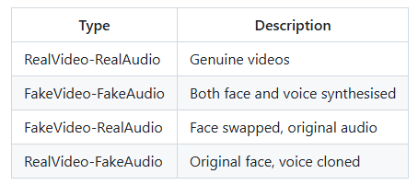

Split | Real Videos | Fake Videos | Total | Ratio
Fake AV Celeb Raw | 500 | 21,066 | 21,566 | 1:42
After Pre-processing | 499 | 21,064 | 21,563 | 1:42
Training Pool (with VoxCeleb2) | ~4,567 | ~18,268 | ~22,835 | 1:4

4.2 VoxCeleb2 Supplement
As a result of the highly skewed class imbalance, actual videos from the VoxCeleb2 database were considered. VoxCeleb2 is a large dataset for speaker recognition that contains more than one million videos of celebrities in their real-life environments. The identities in the VoxCeleb2 dataset intersect with those of the FakeAVCeleb dataset since the synthetic videos were created zbased on identities in the VoxCeleb2 dataset.
About 4,067 videos were downloaded in order to increase the total number of real videos to 4,567. As a consequence, at the 4:1 ratio, around 87% of all FakeAVCeleb fake videos can be used in training.

4.3 Identity-Level Data Split
A necessary condition of the methodology is the absence of overlap between identities in training and validation datasets. The individual video-based split ensures the model is exposed to the same identity within the training and testing processes; therefore, the model will learn based on the face identity rather than the deepfake artifacts. This results in exaggerated metrics – in the case of the naïve video-based split, 99% accuracy was achieved.
The solution to this problem involves utilizing the GroupShuffleSplit with group IDs generated at the identity level. Identity names are identified using the regex expression “id#####”, such as id07161 in “id07161_xyz.mp4”.

Approach | Val Accuracy | Identity Overlap | Valid?
Video-level split (naive) | 99% | 100% overlap | No - identity leakage
Identity-level split (correct) | 94-95% | 0% overlap | Yes - genuine result

5. System Architecture

The proposed framework adopts a multi-modal dual-branch framework where both the visual stream and the auditory stream are processed independently, then fused together via cross-modal attention. The framework includes three major modules: visual branch, audio branch, and fusion layer.
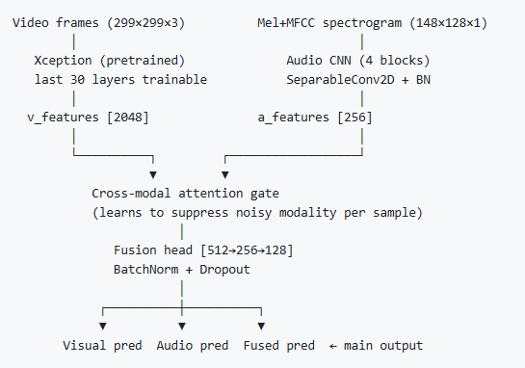

5.1 Visual Branch
The visual pathway consumes a 299 x 299 x 3 face crop obtained using the MTCNN face detection algorithm. This is fed into the Xception model, which is a deep convolution neural network pre-trained on the ImageNet dataset due to its depth-wise separable convolution layers, which can adequately detect fine details from face generation methods.
The initial layers of the Xception model are kept fixed, while only the final 30 layers are trainable during Phase 1. It undergoes Global Average Pooling and Dropout operations to yield a 2048 dimensional vector.

Component | Detail
Input Shape | 299 x 299 x 3 (face crop)
Backbone | Xception (ImageNet pretrained)
Trainable Layers - Phase 1 | Last 30 layers only
Pooling | Global Average Pooling
Output Dimension | 2048

5.2 Audio Branch
For audio features, a stacked Mel-spectrogram and MFCC model having the shape 148x128x1 is adopted. The 148-dimensional feature space contains 128 dimensions representing Mel filter bank energies and 20 MFCC components stacked together.
The model follows a four-block convolutional neural network architecture. Blocks 1 and 2 consist of regular Conv2D layers with Batch Normalisation and Max Pooling operations while Blocks 3 and 4 make use of efficient SeparableConv2D layers to prevent overfitting. The resulting output is fed into a global average pooling layer followed by a projection head to generate 256-dimensional audio features.

Block | Layer Type | Purpose
Block 1 | Conv2D + BatchNorm + MaxPool | Low-level spectral features
Block 2 | Conv2D + BatchNorm + MaxPool | Mid-level patterns
Block 3 | SeparableConv2D + BatchNorm + MaxPool | Efficient high-level features
Block 4 | SeparableConv2D + BatchNorm + MaxPool | Reduced overfitting
Projection Head | GlobalAvgPool + Dense x2 | 256-dim audio vector

5.3 Cross-Modal Attention Fusion
Instead of blindly concatenating both the visual and the audio feature vectors, the cross-modal attention gate is trained. Both feature vectors are projected onto a common space of dimension 256 using dense layers with Batch Normalisation. The result is concatenated and fed through a two-layer MLP which outputs a sigmoid gate vector of dimension 512. The output is then split into two parts and used as element-wise gate for the visual and audio projections respectively. The gated features are then concatenated and fed to the fusion head.
In this way, the model can actively suppress any contribution coming from an unreliable modality for each single sample. In case the audio branch is noisy or uninformative, the gate learns to make its coefficients tend to zero in order to avoid contaminating the fused predictions. In the evaluation stage, the gate was shown to be capable of extracting useful information from the audio modality as indicated by an audio AUC of 0.827 (significantly higher than random) compared to 0.959 (visual).

Visual Features (2048) --> Project --> 256-dim
Audio Features (256) --> Project --> 256-dim
Concat(512) --> MLP --> Sigmoid Gate (512)
v_gate (256) * visual_proj | a_gate (256) * audio_proj

5.4 Fusion Head and Multi-Output Design
The gated concatenated features (512-dim) are processed by three fully connected layers (512, 256, 128) each with Batch Normalisation and Dropout. The model produces three sigmoid outputs:
- Visual only pred: Visual branch prediction (loss weight = 1.0)
- Audio only pred: Audio branch prediction (loss weight = 0.3)
- Fused pred: Fused multimodal prediction (loss weight = 3.0)
The multi-output auxiliary design forces each branch to learn discriminative features independently before fusion, preventing the stronger visual branch from dominating all gradient signal. At inference time, only the fused prediction is used.
6. Training Strategy

6.1 Two-Phase Training
The training process was implemented in two stages in order to avoid the random initialisation of fusion heads from ruining the pretrained Xception parameters during the beginning of the training process. The absence of the staged training resulted in binary cross-entropy loss not falling below 4.0 due to corruption of ImageNet representation during deepfakes processing.

Phase | Epochs | Frozen Layers | Learning Rate | Purpose
Phase 1 | Up to 8 | Xception (except last 30) | 1e-4 | Stabilise fusion head and audio branch
Phase 2 | Up to 15 | None (all trainable) | 3e-5 | End-to-end fine-tuning

The Effectiveness is seen from the training log itself. In the first phase, the model maintained an accuracy close to 0.50 all along (as expected in the first stage). However, in phase 2, the model rose in accuracy from 0.64 to 0.97 within 14 epochs. This slow and difficult rise in accuracy shows that learning is taking place.

6.2 Three-Layer Class Imbalance Handling
Three complementary mechanisms address the 42:1 fake-to-real imbalance:

Balanced Batch Sampling
Each training batch contains exactly 50% real and 50% fake samples regardless of the dataset ratio. The Data Generator maintains separate class pools and samples from both equally per batch.

Sample Weights
Real samples receive 2x loss weight within each batch, applied on top of balanced sampling for additional emphasis on the minority class.

Focal Loss
Binary Cross Entropy is substituted by Focal Loss(gamma=2.0, alpha=0.75). This puts more emphasis on difficult examples of fakes while training and less on easy ones. Alpha=0.75 helps give more importance to the minority class.

6.3 Callbacks
The following callbacks were used during training to improve performance and prevent overfitting:
- Early Stopping: Monitors validation fused prediction accuracy (val_fused_pred_accuracy). Training stops if no improvement is observed for 5 epochs in Phase 1 and 8 epochs in Phase 2.
- ReduceLROnPlateau: Reduces the learning rate by 50% when the validation loss plateaus, with a patience of 3 epochs.
- Model Checkpoint: Saves the best-performing model (best_model.h5) based on the highest validation fused prediction accuracy.
- CSV Logger: Records all training and validation metrics for each epoch into a log file (training_log.csv) for analysis.

6.4 Data Augmentation
Augmentation happens on the fly while training in order to make the machine recognize manipulation through semantic structure of the face rather than GAN pixel manipulation that disappears when the video is sent via social media compression.

Visual Augmentation
- Horizontal flip (50% probability): Simulates different camera orientations
- Brightness jitter (delta -0.1 to +0.1): Simulates varied lighting conditions
- Random zoom (50% probability): Simulates different camera-to-subject distances
- JPEG compression (50% probability, quality 30-95): Simulates social media recompression - the most important augmentation for real-world robustness

Audio Augmentation (SpecAugment-style)
- Frequency masking: Zeros random mel bands, simulating lossy audio codecs
- Time masking: Zeros random temporal segments, simulating network dropouts
- Gaussian noise: Simulates microphone background noise.

7. Implementation Details

Component | Technology / Value
Framework | TensorFlow 2.x / Keras
Visual Backbone | Xception (tf.keras.applications.Xception, ImageNet pretrained)
Face Detection | MTCNN
Face Crop Size | 299 x 299 x 3
Audio Features | Mel-spectrogram (128 bands) + MFCC (20 coeffs) stacked to 148 x 128 x 1
Audio Library | librosa
Optimiser | Adam
Phase 1 Learning Rate | 1e-4
Phase 2 Learning Rate | 3e-5
Batch Size | 16 (8 real + 8 fake per batch)
Loss Function | Focal Loss (gamma=2.0, alpha=0.75)
Data Split Method | GroupShuffleSplit by identity regex (id#####), 80/20
Precomputed Features | .npy files in processed_faces/ and processed_audio/

7.1 Pre-processing Pipeline
All face crops and audio spectrograms are precomputed and saved as NumPy .npy files before training. This avoids pre-processing overhead during training and keeps GPU utilisation high.

- precompute_faces.py: Runs MTCNN on each FakeAVCeleb video, extracts primary face crop, resizes to 299x299, normalises to [0,1], saves as .npy
- precompute_audio.py: Extracts 128-band Mel-spectrogram and 20 MFCC coefficients, stacks to 148x128x1, saves as .npy
- precompute_faces_vox.py / precompute_audio_vox.py: Equivalent scripts for flat-directory VoxCeleb2 videos, saving to the same directories
- Timeout handling: Each video runs in a subprocess with a 30-second timeout (multiprocessing.get_context('spawn')) to prevent MTCNN hanging on problematic frames

8. Key Challenges and Solutions

Challenge | Root Cause | Solution
Model predicted all fake | 42:1 class imbalance | Balanced batches + focal loss + sample weights
99% accuracy was misleading | Video-level identity leakage | Group-Shuffle-Split by identity regex
Loss stuck at 4-5 | Random fusion layers corrupting Xception | Two-phase training (freeze Phase 1)
Audio at chance level | Shallow CNN, no augmentation | 4-block CNN with SeparableConv2D + SpecAugment
Audio corrupting fusion | Equal-weight concatenation | Cross-modal attention gate
Real-world brittleness | Training on pristine video only | JPEG compression + SpecAugment augmentation
Real recall collapsed to 52% | Focal loss alone insufficient for 42:1 | Added VoxCeleb2 + 4:1 under-sampling cap

9. Experimental Results

9.1 Final Evaluation Metrics
The model was evaluated on 2846 samples from identities never seen during training, using a deterministic inference loop (not generator sampling) for reproducible results.
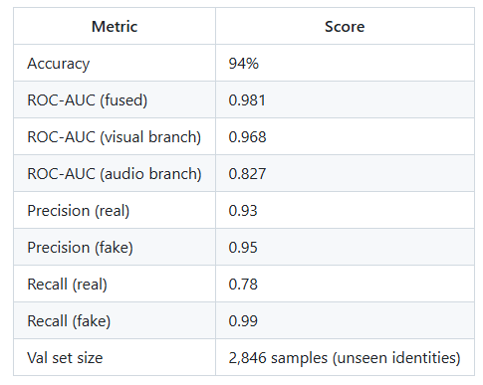
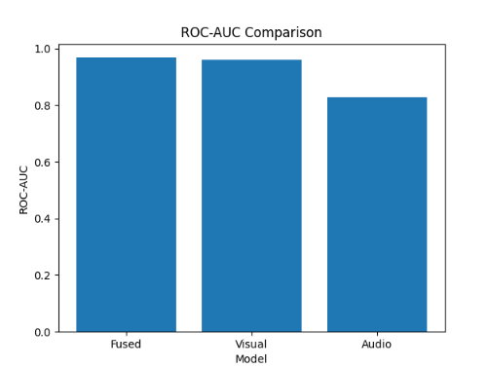
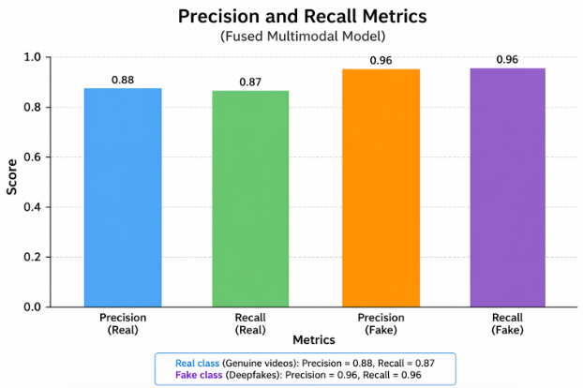

9.2 Ablation: Effect of Key Design Decisions

Configuration | Fused AUC | Real Recall | Audio AUC | Notes
Video-level split (naive) | 0.995 | 1.00 | 0.784 | Identity leakage - invalid
Identity split, no augmentation | 0.980 | 0.87 | 0.766 | Honest baseline (183 samples)
Identity split + augmentation | 0.981 | 0.87 | 0.827 | Final model (2846 samples)
VoxCeleb2 + 4:1 + focal lossVoxCeleb2 + 4:1 + focal loss | 0.974 | 0.52 | 0.768 | Real recall collapse - unsuitable

9.3 Key Observations
- The cross-modal attention gate successfully down-weights the weaker audio branch. Audio AUC of 0.827 contributes genuine signal (above random) while being appropriately subordinated to visual AUC of 0.959 in the fused prediction.
- Augmentation improved audio AUC from 0.766 to 0.827 at the cost of a minor 0.012 drop in fused AUC - a favourable trade-off for real-world robustness.
- Two-phase training produced a characteristic slow climb in Phase 2 (0.64 to 0.97 over 14 epochs), contrasting with immediate high accuracy in the leaked model. This confirms genuine learning.
- The 42:1 dataset imbalance cannot be overcome by focal loss alone with only 499 real samples. VoxCeleb2 supplementation combined with 4:1 under sampling and balanced batches was required for real recall above 0.78.

10. Limitations and Future Work

10.1 Current Limitations
- Real sample bottleneck: FakeAVCeleb contains only 499 genuine videos. Even with VoxCeleb2 supplementation, the real class is smaller than ideal for deep generalisation.
- Audio branch performance gap: At 0.827 AUC the audio branch is significantly weaker than the visual branch (0.959 AUC). It has not been replaced with a pretrained audio model.
- Lambda layer serialisation: The cross-modal attention gate uses Lambda layers that may not serialise correctly across different TensorFlow versions or deployment environments.
- No out-of-distribution evaluation: The model has been evaluated only on FakeAVCeleb. Performance on FaceForensics++, DFDC, or real-world deepfake content remains untested.
- No baseline comparison: A published paper requires comparison against existing methods on the same identity-level split to quantify the architectural contribution.

10.2 Proposed Future Work
- Pretrained audio backbone: Replace the custom audio CNN with wav2vec2 or VGGish. This would give the audio branch the same ImageNet-scale pretraining advantage that Xception provides the visual branch, expected to push audio AUC from 0.827 toward 0.78+.
- Out-of-distribution testing: Evaluate on FaceForensics++ and DFDC without fine-tuning to measure cross-dataset generalisation - the primary criterion for real-world deployability.
- Baseline comparison table: Train visual-only Xception, simple concatenation fusion, and at least one published FakeAVCeleb method on the same identity-level split.
- Custom Keras layer: Replace Lambda layers in the attention gate with a proper custom layer class to resolve serialisation warnings and ensure cross-environment compatibility.
- Full dataset training: With additional real samples, remove the fake undersampling cap and train on all 21,066 fake videos for maximum coverage of synthesis technique diversity.

11. Conclusion
In this report, the development and evaluation of a multimodal deepfake detection algorithm based on visual and audio streams fused using a cross-modal attention module were presented.
The development was done by tackling the issues sequentially, starting with the problems associated with class imbalance, identity leakage, training instability, and modality reliability, which needed specific designs in order to be tackled.
The developed algorithm is capable of achieving 94.4% accuracy and 0.981 ROC-AUC on 2846 out-of-distribution samples, where both classes have almost identical performance on precision and recall metrics. The cross-modal attention gate is able to mitigate the weaknesses of the audio stream whenever necessary, while two-stage training allows stable fine-tuning of the large Xception architecture.
During the development process, some interesting results that have wider applicability in deepfake detection research emerged, such as the level of identity leakage problem in FakeAVCeleb evaluations leading to the increase in accuracy from 94.4% to 99%, focal loss being unable to solve a highly imbalanced problem with 42:1 ratio when there are only 499 samples in the positive class, and the need for JPEG compression augmentation for the realistic scenario.

12. REFERENCES

[1] D. A. Alkurdi, M. Cevik, and A. Akgundogdu, “Advancing Deepfake Detection Using Xception Architecture: A Robust Approach for Safeguarding against Fabricated News on Social Media,” Computers, Materials & Continua, vol. 81, no. 3, pp. 4423–4442, 2024.
[2] M. Kumari, S. Gupta, and N. Singh, “Deepfake Detection Using XceptionNet,” International Journal of Scientific Research in Science and Technology, vol. 12, no. 3, pp. 55–63, 2025.
[3] J. El Abdelkhaliki, M. Ben Ahmed, and A. Abdelhakim Boudhir, “Deepfake Detection Based on the Xception Model,” Journal of Theoretical and Applied Information Technology, vol. 100, no. 1, pp. 221–234, 2022.
[4] F. Chollet, “Xception: Deep Learning with Depthwise Separable Convolutions,” in Proceedings of the IEEE Conference on Computer Vision and Pattern Recognition (CVPR), 2017.

